Missionary Newsletter from East Angola Annual Conference
Missionary: Kutela Katembo Dieudonne
Mission: Quessua UMC Agriculture Center

E-mail:kkatembo@umcmission.org Tel :(00244) 925213393

July 2022

Dear friends and family in Christ, receive our warm greetings in the name of our Lord Jesus Christ. It is our duty and pleasure to inform you about my ministry that is God’s mission at the Quessua UMC Mission,where I serve a needy community while improving as well the Quessua agriculture farm.
The Quessua UMC Mission farm is the agriculture center for the community and together we are grateful for the blessings of your support that enables us to address the food insecurity needs of many households.

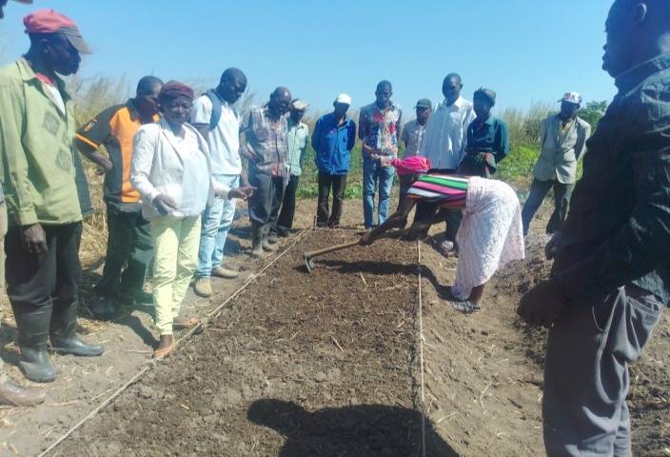
village gardeners receiving training in seed bed preparation

For the past two months the Quessua farm has been providing vegetable planting training for village farmers. We are in the dry season in Angola and this is the best time for vegetable gardens that heavy rains often destroy. The Quessua farm encourages households to use the land as a source of food to improve their livelihoods. Dry season months are lean months for villagers when produce is scarce in their gardens; hence, vegetable gardening is important, particularly in preventing child malnutrition.

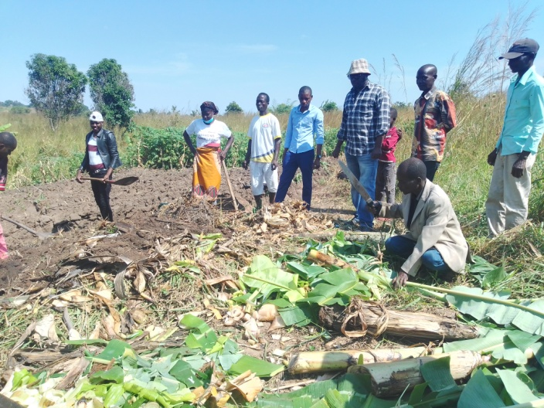
Trainingfor compost preparation

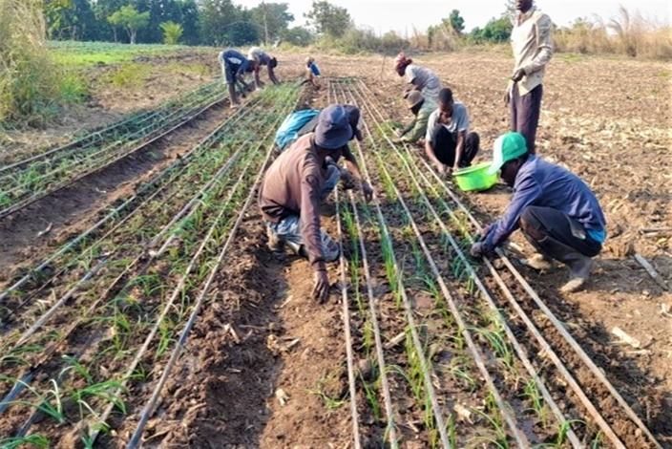
Teaching onion planting

Subsistence agriculture is the primordial activity of the peasant farmers and is the main and sometimes only source of food for their livelihood. We strive to help families grow and provide food for their families for their lifetimes hoping that this will help them provide for their malnourished and undernourished children.

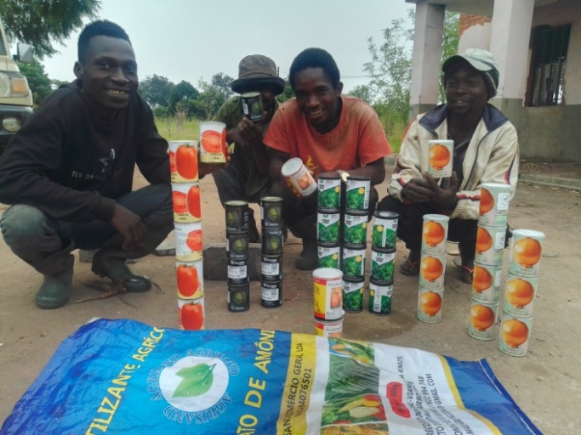
Purchased vegetable seeds

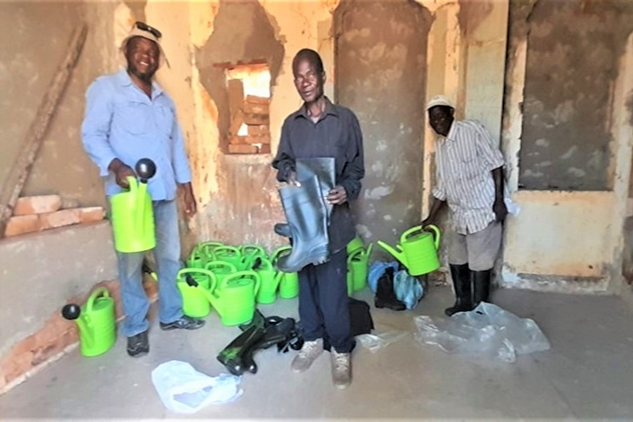
Watering cans and boots for gardeners

Vegetable seeds, watering cans, boots and sprayers were purchased and distributed to villagers in agriculture extension groups. This is a productive way that we can help them since many are unable to purchase these items. We receive many grateful testimonies from beneficiaries thankful for the blessing of this program and your support to them.

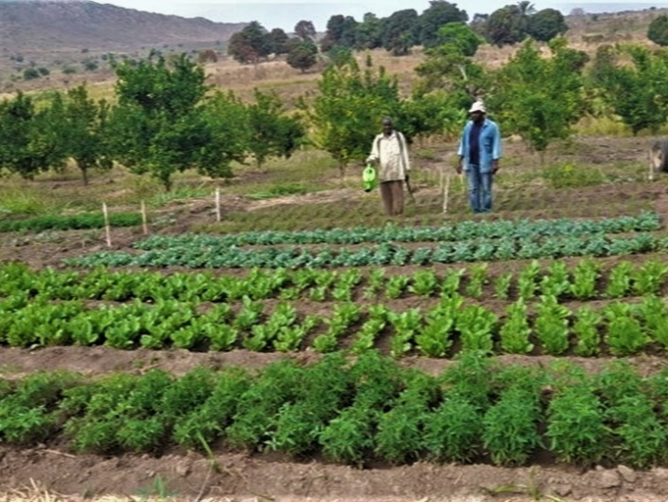
.

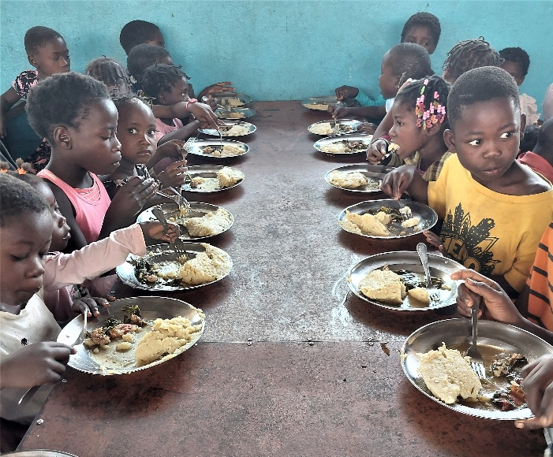

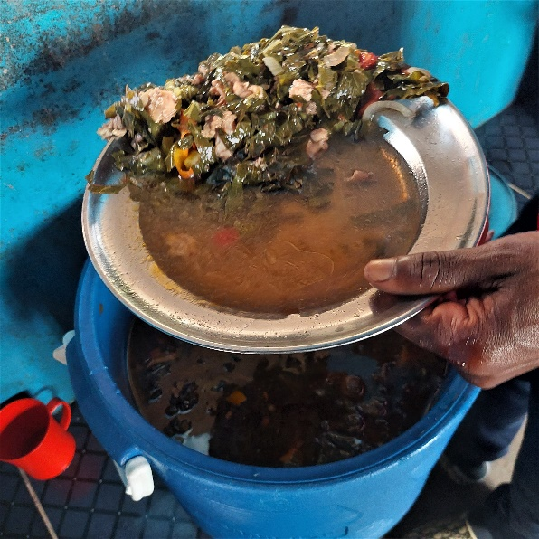

Collard greens from the mission farm help provide a nutritious Sunday meal for 500 or more village children. The meals are coordinated by missionary colleagues. When available, the farm also helps provide corn meal and manioc flour for the “funge” staple. For many of the children this is their main nutritious meal of the week.

ADVANCE SPECIAL NUMBERS:

Partner with me,
I am very grateful for the support you continue to give to our project and to myself the missionary. There are two ways to make your contributions:

-Advance # 3022272(Quessua farm project support)
-Advance#3022031(Kutela salary support)

1. Utilizing the Global Ministries website: www.umcmission.org. To donate for my project and salary support, at the bottom of the page, click on “Missionaries”, scroll to my name on the page and my profile will appear. At the bottom of my profile is a link to make an online donation.

2. Mail a check. Make your check payable to ADVANCE GCFA.Write “For support of Missionary Kutela Katembo.
Advance # 3022272 or # 3022031”Send your check to ADVANCE-GCFA, 458 Ponce de Leon Ave.N.E; Atlanta, GA. 303083. Through your Conference office indicating “for Kutela Katembo”,

STAY IN TOUCH!
I thank you for your support and friendship. Please stay in touch with the Quessua
Agriculture Center Team on the following platforms:
Email: kkatembo@umcmission.org
Facebook: @QuessuaAgCenter

God Bless you! - Kutela

