Missionary Newsletter from East Angola Annual Conference
Missionary: Kutela Katembo Dieudonne
Mission: Quessua UMC Agriculture Center

E-mail:kkatembo@umcmission.orgTel:(00244) 925213393

October 2022
Dear faithful brothers and sisters of God and fellow workers of Christ, I greet you in the name of our Lord and Savior Jesus Christ. Grace and peace be unto you!

I am especially grateful that post pandemic, life has now returned to normal here at Quessua.
At the end of July,I attended the East Angola annual conferenceafter there not being several conferences due to Covid restrictions on public gatherings and even travel at the beginning. It was great to meet and become reacquainted with lay and clergy leaders whom I had not seen for some time. I presented my report, and was asked to convey gratitude to you, our supporters, who have made it possible for us to do so much even during the pandemic.
We are very grateful for your continued support. Your generous giving enabled us to continue giving gifts of seeds and tools to the vulnerable peoples of God that live in villages surrounding the UMC Quessua Mission.

On behalf of The Quessua Agriculture Center, its staff and beneficiaries, I would like to express my deepest gratitude and appreciation to God, and to you who answer the call to sow into Quessua’s growth. Your support enables us to reach out to the poor, the orphans,and widows by addressing the food insecurity needs of many households

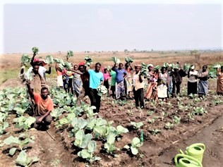
Gardeners from across the Lombe River in Sona Village show some of their produce

Subsistence agriculture is the primordial activity of the peasant farmer and it is the main and sometimes only source of food for their livelihood. We strive to help families grow and provide food for their families for their lifetimes hoping that this will help them provide for their malnourished and undernourished children.

It has been gratifying to see families harvesting their vegetables and being able to sell extra produce for some cash that helps them purchase some needed items at home. The mission garden worker families have also learned to do this, selling produce from their own extra vegetable plots.

9 village agriculture extension groups from the Quessua villages benefited from our recent training and support during the dry season vegetable growing season. Dry season months are lean months for villagers when produce is scarce in their gardens; hence, vegetable gardening is important, particularly in preventing child malnutrition.Once heavy rains return, it becomes difficult to grow vegetables like tomatoes, onions, cabbage, and collard greens which is why these are emphasized during the dry months. Cassava, pumpkin, bean and amarynth leaves, along with okra flourish again and become the main vegetables. The Quessua farm encourages households to use the land as a source of food to improve their livelihoods.

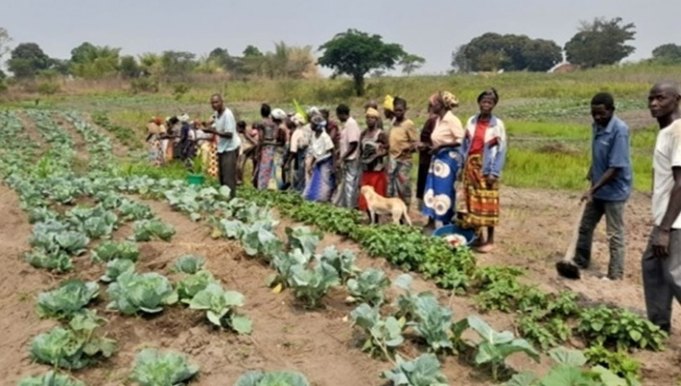
Mufongo village group
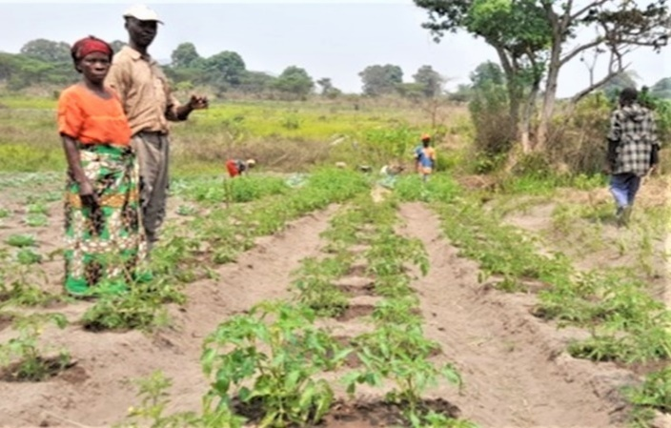
Mufungo village couple withtheir tomato plants

3 villages were newly included this year and it was particularly challenging because although still part of Quessua Mission, they live across the Lombe River. Villagers there have an even more challenging life due to the distance and the precariousness of their foot bridges that often become impassable in the height of the rainy season.

It has been gratifying to work with these people and to introduce many of them to vegetable gardening. Designated trainers went to these villages almost daily to
accompany and supervise the efforts of the villagers. The participants came over to Quessua a couple of times for formal training in the high school auditorium and also to help plant the new peanut crop. Nutritious meals are made at the farm for village groups that come for training or to help harvest or plant. These activities on the mission are empowering to villagers and it helps them feel like a part of the wider community.
Most of the village groups that we collaborated with did quite well with resulting successful harvests. Mufongo village however, stood out and I was particularly impressed with and appreciated their work. The 40 villagers and their coordinator followed instructions given to them and the proof was in their fantastic yield.
The Quessua Agriculture center decided to gift a water pump to the Mufongo ag extension group. Watering a delicate vegetable seed bed and garden by hand with watering cans with water carried from a source is a tedious, time-consuming task. The hope is that the pump will be an incentive to motivate them each year to continue to growdry season vegetables.

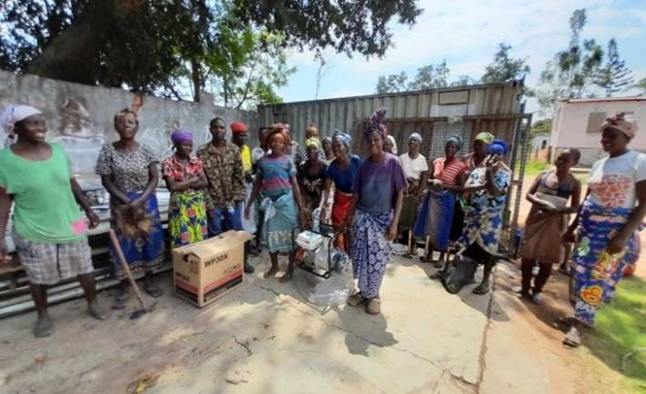
Mufungo gardeners receiving a water pump

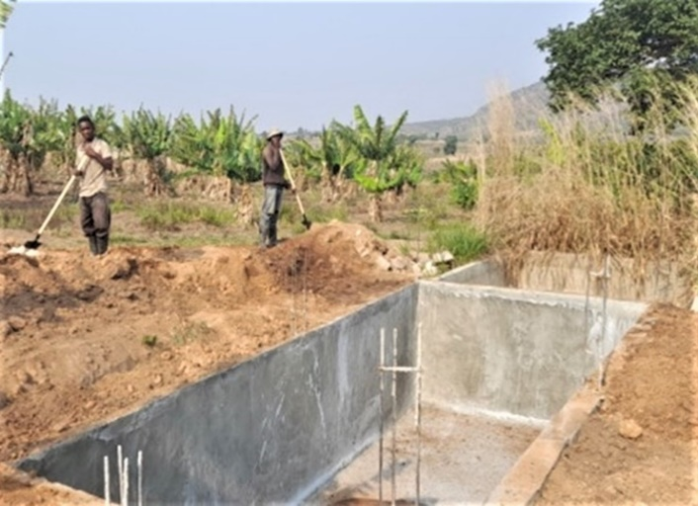
Construction of an underground concrete water tank for irrigatingthe banana orchard.

The Quessua banana orchard flourishes with the rains but during the dry season the plants suffer from lack of water. In searching for a solution to this,an underground water tank was constructed to help with the irrigation of the 850 banana trees, needed all the more with the new banana shoots planted this year.

ADVANCE SPECIAL NUMBERS:

Partner with me,
I am very grateful for the support you continue to give to our project and to myself the missionary. There are two ways to make your contributions:

-Advance # 3022272(Quessua farm project support)
-Advance#3022031(Kutela salary support)

1. Utilizing the Global Ministries website: www.umcmission.org. To donate for my project and salary support, at the bottom of the page, click on “Missionaries”, scroll to my name on the page and my profile will appear. At the bottom of my profile is a link to make an online donation.

2. Mail a check. Make your check payable to ADVANCE GCFA.Write “For support of Missionary Kutela Katembo.
Advance # 3022272 or # 3022031”Send your check to ADVANCE-GCFA, 458 Ponce de Leon Ave.N.E; Atlanta, GA. 303083. Through your Conference office indicating “for Kutela Katembo”,
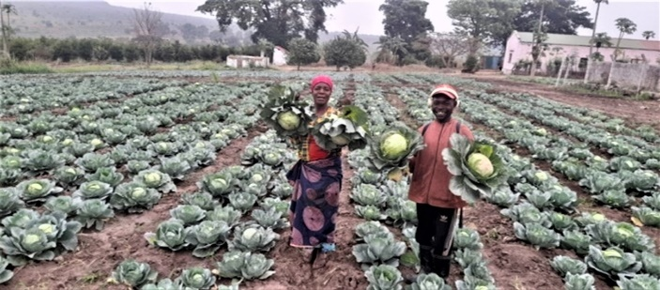

STAY IN TOUCH!
I thank you for your support and friendship. Please stay in touch with the Quessua
Agriculture Center Team on the following platforms:
Email: kkatembo@umcmission.org
Facebook: @QuessuaAgCenter

God Bless you! – Kutela

